- Name duplicate in everywhere: system should not allow name duplication in any place, please consider the following pages where name duplicate is denied:
- Departments
- Designations
- All System setting lists

- On adding new department, remove the user type selector

- Organization chart not loading on offline version

- Department list and designation list: add search by name

- Tickets Status Change:
  - Only user can change ticket status as the following order:
Open -> in progress or cancelled -> Resolved
  - You should not change ticket from open to resolved directly
  - You should not change ticket status from closed to in progress
  - Once any ticket is resolved there should be an option to reopen the ticket

- Resolved tickets page design must be changed as previous meeting point, it should appear in boxes and not as a list

- Assets page:
  - remove the word “company” from the title
  - On adding a new asset, the system should not add a date for purchase and expiry, it should be empty without any date
  - In asset details page, asset assign and asset status change must be separate buttons
  - In asset details page, there should be a quick option to change asset description
  - On asset bar code print page, only show the barcode and remove everything else
  - On asset filter, add all assets status
    - 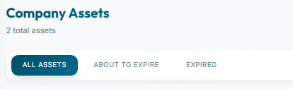

- Allow email or username when adding new employee
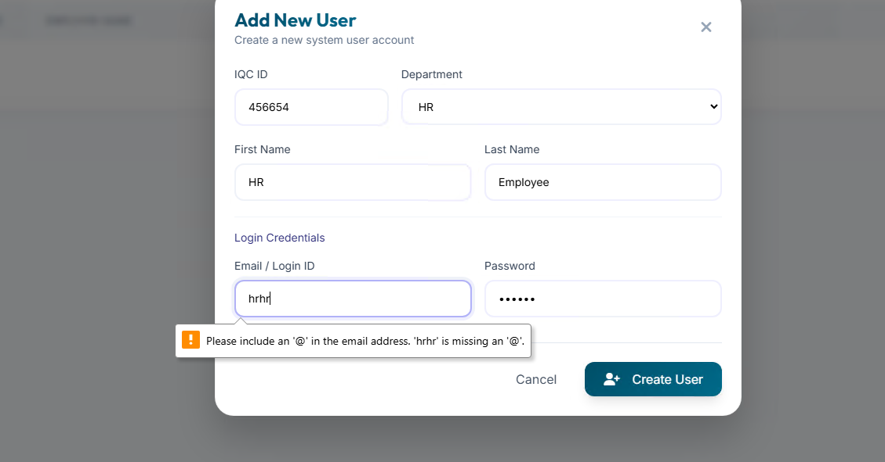

- Add ability to change employee login ID in root with a comment
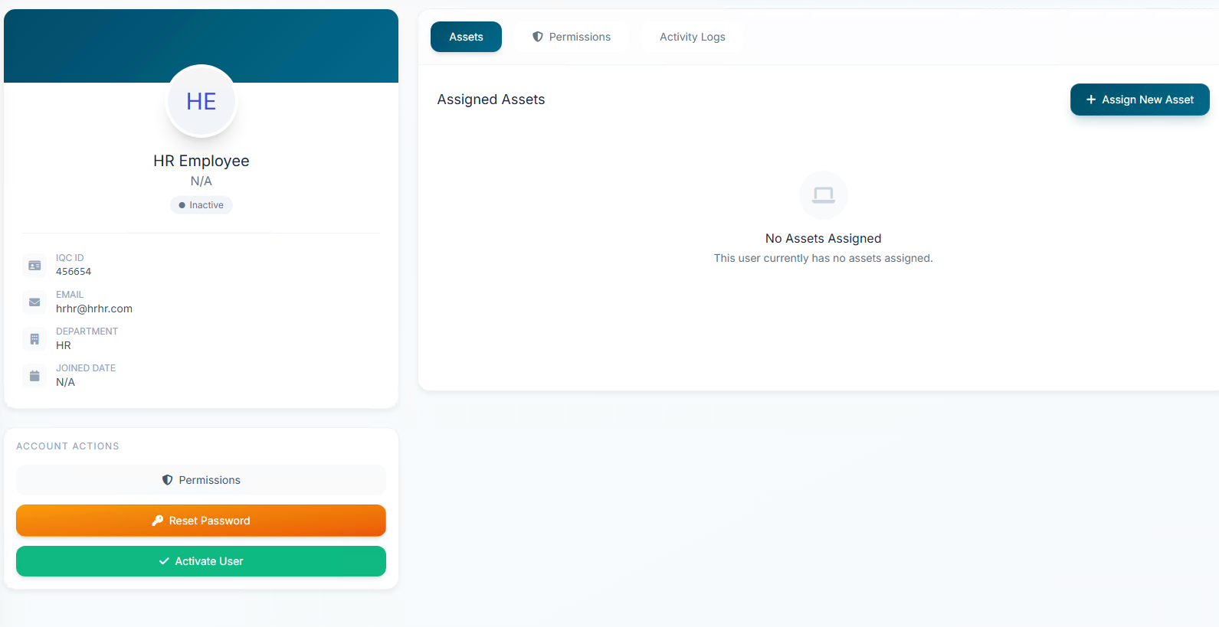

- Activate User must require a comment (Meeting Point)
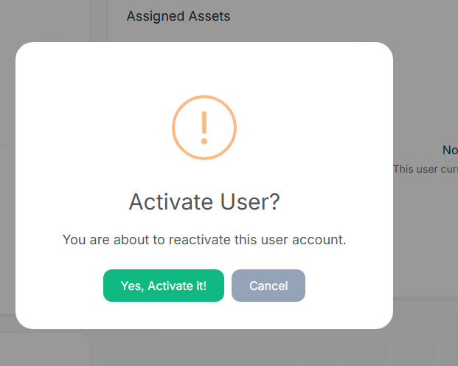

- Rename Permission tab into “services”
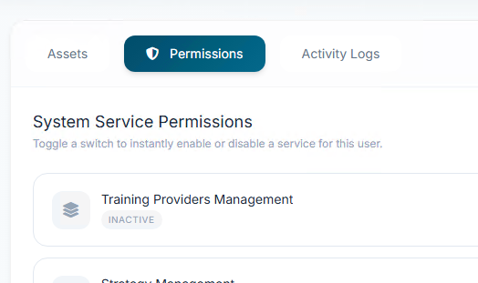

- Inside employee services list, the services must be categorized as follows:
  - External Services
    - Training Providers Management
    - Learner Affairs
    - Claim Certificate

  - HR Services
    - All HR user permissions

  - Strategy Services
    - Strategy Management
    - Operational Planning
    - Self-Studies

  - EQA Services
    - All EQA Services

- Add incident type to system settings

- Remove ticket status from system settings and only keep the old system status without the ability to change it

- In system settings rename the “Service Categories” into “Support Services”

